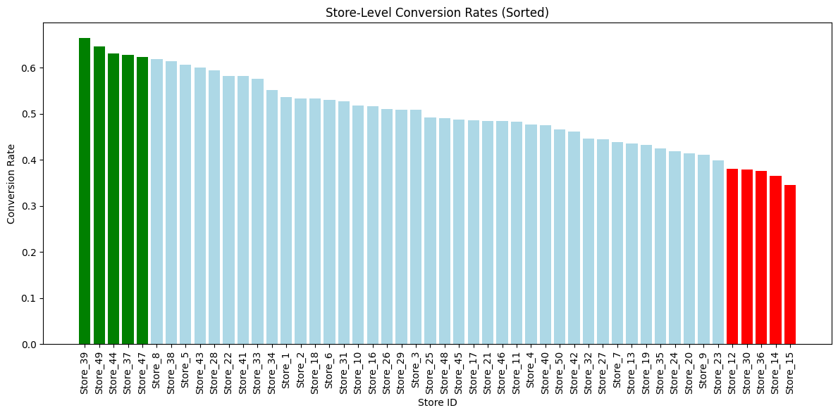

The top 5 performing stores based on conversion rates at store level are store_39, store_49, store_44, store_37, store_47.  
The bottom 5 performing stores based on conversion rates at store level are store_12, store_30, store_36, store_14, store_15.

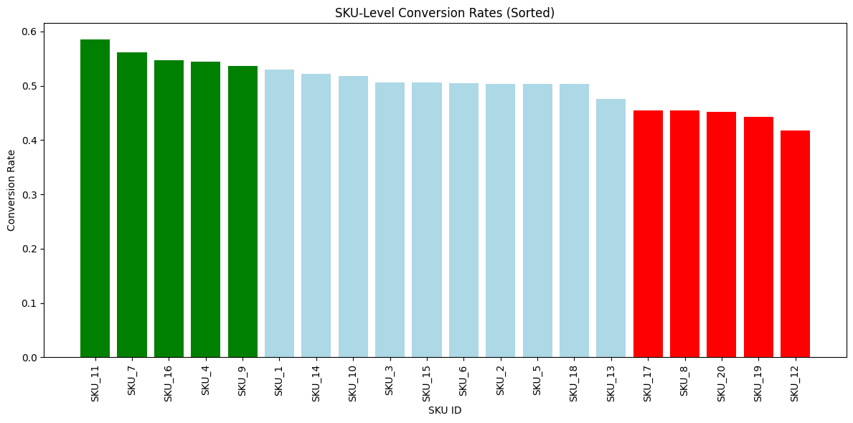

The top 5 performing stores based on conversion rates at SKU level are SKU_11, SKU_7, SKU_16,

SKU_4 and SKU_9.

The bottom 5 performing stores based on conversion rates at SKU level are SKU_17, SKU_8, SKU_20, SKU_19 and SKU_12.

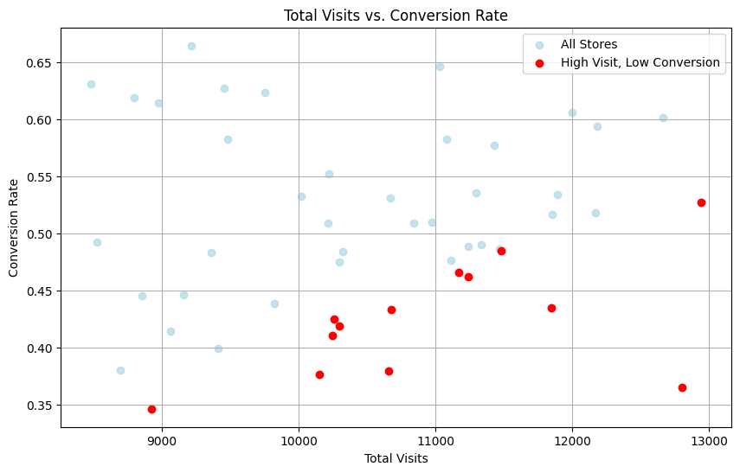

**Trend 1: Stores with High Visits but Low Conversion Rates**

Some stores attract significant foot traffic but fail to convert visitors into buyers, indicating potential issues such as pricing, product availability, or in-store experience.

**Examples**: | Store ID | Total Visits | Conversion Rate |

Store_13 | 11846 | 0.435168 |

| Store_14 | 12804 | 0.365042 |

| Store_15 | 8922 | 0.346335 |

| Store_19 | 10678 | 0.433321 | …

* **Observation**: Stores like Store_13 have high visits (11,846) but conversion rates as low as 43.52%, suggesting untapped sales potential.
* **Implication**: These stores could benefit from improved product displays, staff training, or targeted promotions.

**Trend 2: SKUs with High Revenue but Low Conversion Rates**

Certain SKUs generate substantial revenue despite low conversion rates, likely due to high pricing or niche appeal.

**Examples**: | SKU ID | Revenue | Conversion Rate |

| SKU_13 | 1.46517e+06 | 0.475163 | | SKU_15 | 1.50567e+06 | 0.505578 | | SKU_2 | 1.49893e+06 | 0.504142 | | SKU_3 | 1.60643e+06 | 0.506085 | | SKU_7 | 1.67402e+06 | 0.561391 |

* **Observation**: SKUs like SKU_13 generate $1,465,168.53 in revenue but have a conversion rate of only 47.52%.
* **Implication**: These SKUs may be premium products. Consider bundling or discounts to boost conversion rates while maintaining revenue.

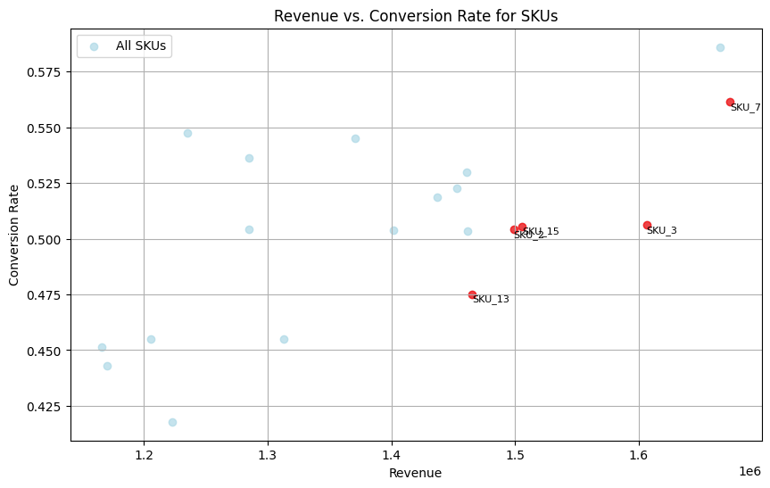

**Trend 3: Significant Variation in SKU_1 Performance Across Stores**

SKU_1 shows considerable variation in conversion rates across stores, indicating store-specific factors like location or customer demographics.

**Examples**: | Store ID | Conversion Rate | Total Visits | Transactions |

| Store_28 | 0.997275 | 734 | 732 | | Store_32 | 0.991128 | 789 | 782 | | Store_33 | 0.979701 | 936 | 917 | | Store_39 | 0.966834 | 995 | 962 | | Store_16 | 0.958738 | 412 | 395 | | Store_20 | 0.0289855 | 345 | 10 | | Store_17 | 0.0336606 | 713 | 24 | | Store_22 | 0.0578387 | 657 | 38 | | Store_19 | 0.0851689 | 681 | 58 | | Store_12 | 0.0924262 | 779 | 72 |

* **Observation**: SKU_1 has conversion rates ranging from 2.90% in Store_20 to 99.73% in Store_28.
* **Implication**: High-performing stores could share best practices (e.g., marketing, placement) with low-performing ones to improve consistency.

**Recommendations**

1. **Optimize Underperforming Stores**:
   * For stores like Store_12, investigate barriers to purchase (e.g., stock availability, staff training, or pricing). Implement targeted promotions to boost conversions.
2. **Enhance Low-Performing SKUs**:
   * For SKUs like SKU_17, consider price adjustments, improved product descriptions, or bundling with high-performing SKUs to increase appeal.
3. **Leverage High-Performing SKUs**:
   * Scale successful SKUs like SKU_11 by increasing inventory in high-performing stores and replicating marketing strategies in underperforming stores.
4. **Address High-Visit, Low-Conversion Stores**:
   * For stores like Store_13, conduct customer feedback surveys to identify pain points (e.g., long checkout times, product visibility) and optimize the shopping experience.

**Reasoning**

* **Data-Driven Insights**: The analysis highlights specific stores and SKUs with actionable metrics (e.g., conversion rates, revenue). For example, low conversion rates in high-visit stores suggest operational or experiential issues.
* **Targeted Interventions**: Recommendations focus on addressing root causes (e.g., pricing for low-conversion SKUs, operational improvements for stores) to maximize impact.
* **Scalability**: Leveraging high-performing SKUs and stores ensures efficient resource allocation, driving overall sales growth.

For **SriMandir,** I recommend a small team of 5 people acting as a single unit (centralized team). This is easy and organized. Below are their roles and what they are supposed to do:

**Data Team Leader (1 person):**

* Consolidates the team and determines what data work to be performed.
* Talks to business heads (such as Commerce or Travel managers) to get to know what they need.
* Ensures all of them work in harmony and provide reports on time.

**Business Analysts (2 people):**

* One for Puja and Chadhava: Examines facts such as numbers of people who order rituals or purchase offerings. Informs these companies what the customers prefer.
* One for Commerce and Travel: Verifies sales facts or holiday bookings. Watches to see how they can sell more or offer better services.
* They meet with business groups and ask, "What do you need to know?" and then collaborate with the Data Analysts to obtain it.

**Data Analysts (2 people):**

* Work with data by applying tools such as Excel, SQL, or Tableau.
* Create charts and reports, such as indicating the best-selling products in Commerce or the temples where most Puja bookings have taken place.
* Support the Business Analysts by data pulling and data cleaning.

**Why This Structure Works**

* **The Leader keeps everyone accountable**: Business Analysts work on what each business requires (such as Puja versus Travel), and Data Analysts do the technical data heavy lifting.
* **Aids All Businesses:** Two Business Analysts assist all five business segments (Puja/Chadhava both, Commerce/Travel both, and Data Analysts assist Astro as well).
* **Small and Inexpensive**: A team of 5 is sufficient for an expanding business like SriMandir, so it's not a heavy cost.
* **Quicker Work**: With more people, the team can complete data requests quicker, versus one Product Analyst doing everything.